**MICROLECTURE MOBILE LEARNING SYSTEM**

A Project Report

*Submitted by:*

JABIN JALEEL

LLMC18MCA015

to

*The APJ Abdul Kalam Technological University*

*in partial fulfillment of the requirements for the award of the degree*

*of*

***MASTER OF COMPUTER APPLICATIONS***



**DEPARTMENT OF COMPUTER APPLICATIONS**

LOURDES MATHA COLLEGE OF SCIENCE AND TECHNOLOGY KUTTICHAL, THIRUVANANTHAPURAM

July 2021

**DECLARATION**

I undersigned hereby declare that the project report “**Microlecture Mobile Learning System Based on Smartphone and Web API** ”, submitted for partial fulfillment of the requirements for the award of degree of Master of Computer Applications of the APJ Abdul Kalam Technological University, Kerala is a bonafide work done by me under supervision of Prof. Bismi K Charleys. This submission represents my ideas in my own words and, I have adequately and accurately cited and referenced the original sources. I also declare that I have adhered to ethics of academic honesty and integrity and have not misrepresented or fabricated any data or idea or fact or source in my submission. I understand that any violation of the above will be a cause for disciplinary action by the institute and/or the University.

Place:

Date:

**DEPARTMENT OF COMPUTER APPLICATIONS LOURDES**

**MATHA COLLEGE OF SCIENCE & TECHNOLOGY, KUTTICHAL,**

**THIRUVANANTHAPURAM**



**CERTIFICATE**

This is to certify that the report entitled “Microlecture Mobile Learning System Based on Smartphone and Web API” submitted by JABIN JALEEL to the APJ Abdul Kalam Technological University in partial fulfillment of the requirements for the award of the Degree of Master of Computer Applications is a bonafide record of the project work carried out by him under my guidance and supervision.

Prof. Bismi k Charleys

(Internal Supervisor) (External Supervisor)

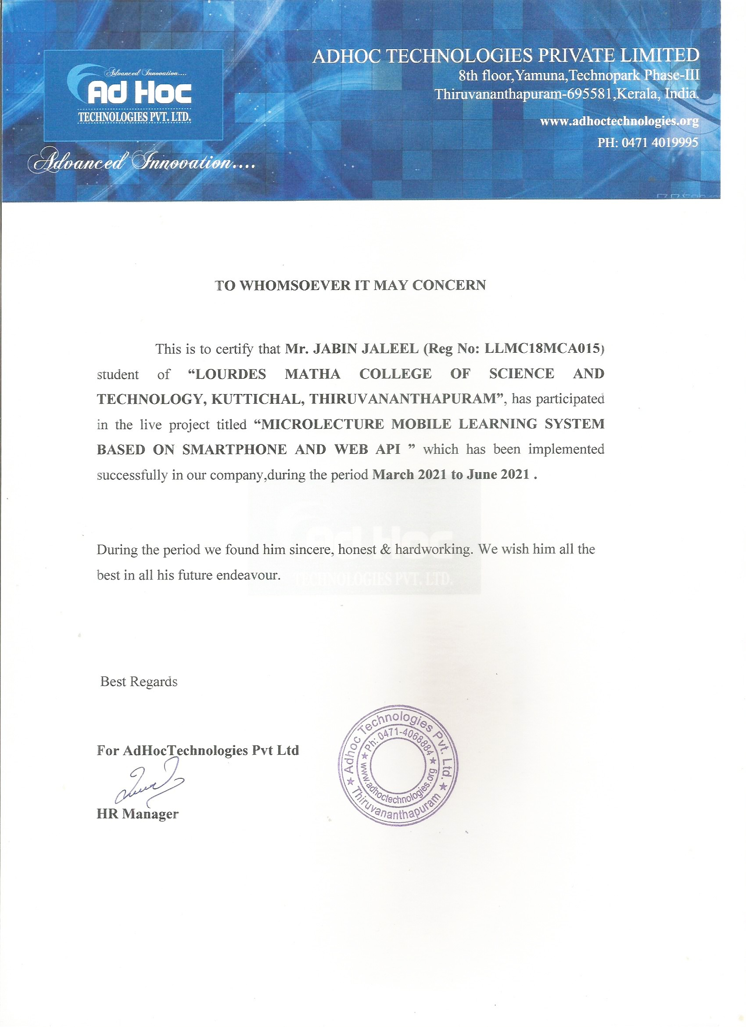

ACKNOWLEDGEMENT

An endeavor over a long can be successful only with advice and support of many well-wishers. I wish to place on record my profound indebtedness and gratitude to all those who have contributed directly or indirectly to make this project work a success. At the very onset, I express my gratitude to God Almighty, who sheltered me under his protective wings and showered on innumerable blessings throughout the period of this Master of Computer Application Course. It is a great pleasure to express my sincere gratitude to Rev. Dr.Tomy Joseph Padinjareveettil, Director and Prof. Dr. P.P. Mohanlal, Principal, Lourdes Matha College of Science and Technology for permitting to do this project with the fullest spirit. I am highly obliged to Mrs. Selma Joseph, Head of the Department of Computer Applications, Lourdes Matha College of Science and Technology, for being the source of inspiration throughout the course and for her valuable guidance. With heart full of thanks, I would like to take up this opportunity to wish my internal guide Mrs. Neethu Mohan Assistant Professor and all staffs of department of computer applications for their endless support, encouragements and suggestions in various stages of the development of this project. Finally, I wish to express my sincere gratitude to all our friends, who directly or indirectly contributed in this venture

ABSTRACT

The rise of mobile cloud computing technology has given a chance to develop various computationally intensive applications for mobile devices. To use this opportunity in education, a new Next Generation Classroom Learning (NGCL) method called “Quiz inline” in the video is introduced. In **Micro lecture Mobile Learning System based on Smart phone and Web API**, the user interacts with the video by answering the quiz at the end of each concept rather than at the end. The context and the questions uploaded are converted into a video. The video starts playing and pauses when the question is displayed and resumes when the student answers the question. Video quizzes need to be streamed continuously even when multiple users access the same video. To achieve the goal, “Online Frame Selection” mechanism is used, where-in which the key frames are extracted and converted to video. In order to facilitate video transmission to the students without any delay, a Platform as a Service mobile cloud environment is used from where those videos and video-quizzes are stored and streamed. By applying computational offloading, the videos are streamed to a group of users in a classroom. In the proposed system user will use mobile application for eLearning. Online/offline video streaming will be available for each and every class, user interacts with the video by answering the quiz at the end of each concept rather than at the end. Also, there will be chatbot available for user to interact at each video session. Thus, user get a feel of live session with a tutor in each and every video class.

**CHAPTER 1**

1. **1.INTRODUCTION**

**1.1 GENERAL INTRODUCTION**

Microlecture Mobile Learning System is a mobile E-Learning application that provides a Digital platform to students for Learning. Online/Offline Classes are available in this application. The main feature of this application is it is a Video analytics Platform in Which a Students activity are continuously monitored during each offline class.

Each Offline Video is divided into Frames and in each frame, video stopes and a questionnaire are asked to the students related to the covered topic. The video continues only after the student answers the question.

Another feature of this application is chat Bot.Chat Bot is available for each offline video classes. Students can clear the doubt using the Chat Bot.So there is no need for a faculty for clearing the doubts of a students and the chat bot is available in 24/7.

**1.2 GOAL OF PROJECT**

The overall goal of MICROLECTURE MOBILE LEARNING SYSYTEM is to provides flexible and feasible environment for learning process. We need more time saving and more accurate learning system as the number of applicants is increasing day by day. Once the videos are uploaded in the system, the system divide the video into different frames and in each frames different questions are asked to the students related to the covered topics. The video continues only after student answer’s the question. This minimizes the chance of “bunking” the offline video classes. Online learning system gives you the flexibility to evaluate and grade Students performance.

**CHAPTER 2**

**2.LITERATURE SURVEY**

**2.1 STUDY OF SIMILAR WORK**

There are some of the similar works for the online e-Learning system but most of the platforms are inefficient in assessing a student’s topic mastery. There is also no mechanism to prevent cheating or other malpractice. Most of the e-Learning application does not have video analytic technology which monitors student activities during offline video classes.

**2.1.1 EXISTING SYSTEM**

In traditional classrooms, teachers can give students immediate face-to-face feedback. Students who are experiencing problems in the curriculum can resolve them quickly and directly either during the lecture or during the dedicated office hours. Personalized feedback has a positive impact on students, as it makes learning processes easier, richer, and more significant, all the while raising the motivation levels of the students.

Existing E-Learning, on the other hand, still tends to struggle with student feedback. Students completing regular assessments become dissatisfied when they experience a lack of personalized feedback. The traditional methods of providing student feedback don’t always work in an E-Learning environment, and because of this, online education providers are forced to look towards alternative methods for providing feedback. Providing student feedback in an online setting is still a relatively unresearched topic area, and it might take a while for any specific strategies to become fully research-based and proven to be effective.

one of the biggest disadvantages of E-Learning continues to be cheating through various methods. Compared to on-campus students, online students can cheat on assessments more easily as they take assessments in their own environment and while using their personal computer. The students cannot be directly observed during assessments without a video feed, making cheat detection during online assessments more complicated than for traditional testing procedures.

## Online student feedback is limited

## Cheating prevention during online assessments is complicated

## E-Learning lacks face-to-face communication

## E-Learning is limited to certain disciplines

## •Lack of accreditation & quality assurance in online education

## 2.1.2 DRAWBACKS OF EXISTING SYSTEM

* Online student feedback is limited as students are unable to receive immediate face-to face responses.
* e- learning is inaccessible to the computer illiterate population or those who are in rural areas with very little access to technology.
* Poor self-motivation among students continues to be one of the primary reasons why students fail to complete online courses. Online learning requires a great deal of discipline and effective time management skills.
* t is difficult to prevent cheating with online learning. Students cannot be directly observed without a video feed.

## e-learning possesses a lack of accreditation & quality assurance that is obtained in traditional learning environments.

**CHAPTER 3**

**3. OVERALL DESCRIPTION**

**3.1 PROPOSED SYSTEM**

Many people and organisations have been forced to find alternative ways to meet their education needs. Innovations of distance education create a new way to provide learning content,unlimited participation and open access through Massively Open Online Courses( MOOCs ) via the web. In addition, mobile learning centered research are sprouting out, anytime, anywhere, anyone learning is becoming what people aspire to. The rise of mobile cloud computing technology has given a chance to develop various computationally intensive applications for mobile devices. To use this opportunity in education, a new Next Generation Classroom Learning (NGCL) method called "Quiz inline" in the video is introduced.

The user interacts with the video by answering the quiz at the end of each concept rather than at the end. The context and the questions uploaded are converted into a video. The video starts playing and pauses when the question is displayed and resumes when the student answers the question. Video quizzes need to be streamed continuously even when multiple users access the same video.

To achieve the goal, "Online Frame Selection" mechanism is used, where-in which the key frames are extracted and converted to video. In order to facilitate video transmission to the students without any delay, a Platform as a Service mobile cloud environment is used from where those videos and video-quizzes are stored and streamed. By applying computational offloading, the videos are streamed to a group of users in a classroom.

In the proposed system user will use mobile application for e learning. Online/offline video streaming will be available for each and every class ,user interacts with the video by answering the quiz at the end of each concept rather than at the end. Also there will be chatbot available for user to interact at each video session. Thus user get a feel of live session with a tutor in each and every video.

**3.2 FEATURES OF PROPOSED SYSTEM**

* Offline video saving.
* Online video streaming.
* Inline mandatory quiz sessions.
* Video analytics.
* Chatbot.
* Online frame selection.
* Online exam.
* Cloud server integration.

**3.3 FUNCTIONS OF PROPOSED SYSTEM**

* Enhancement: The main objective of The MICRO LECTURE MOBILE LEARNING SYSTEM is to enhance and upgrade the existing system by increasing its efficiency and effectiveness. The software improves the working methods by replacing the existing manual system with new features.
* Accuracy: The MICRO LECTURE MOBILE LEARNING SYSTEM provides the uses a quick response with very accurate information regarding the subject marks etc. Any details or system in an accurate manner, as and when required
* User-Friendly: The MICRO LECTURE MOBILE LEARNING SYSTEM has a very user-friendly interface. Thus, the users will feel very easy to work on it.
* Online exam :Assess candidates with multiple exam formats such as MCQs, essay, coding & aptitude.
* The MICRO LECTURE MOBILE LEARNING SYSTEM can Conduct assessments across mobile devices seamlessly and it Flags suspicious activity at each step of the process.

**3.4 REQUIREMENTS SPECIFICATION**

A software requirements specification (SRS) is a detailed description of a software system to be developed with its functional and non-functional requirements. The SRS is developed based the agreement between customer and contractors. It may include the use cases of how user is going to interact with software system. The

software requirement specification document consistent of all necessary requirements required for project development. To develop the software system we should have clear understanding of Software system. To achieve this we need to continuous communication with customers to gather all requirements.

A good SRS defines the how Software System will interact with all internal modules, hardware, communication with other programs and human user interactions with wide range of real life scenarios. Using the Software requirements specification (SRS) document on QA lead, managers creates test plan. It is very important that testers must be cleared with every detail specified in this document in order to avoid faults in test cases and its expected results.

It is highly recommended to review or test SRS documents before start writing test cases and making any plan for testing. Let’s see how to test SRS and the important point to keep in mind while testing it.

**3.5 FEASIBILITY ANALYSIS / STUDY**

The main aim of the feasibility study activity is to determine. Whether it would be financially and technically feasible to develop the product. The feasibility study activity involves analysis of the problem and collection of all relevant information relating to the product such as the different data items which would be input to the system the processing required to be carried out of these data, the output data required to be carried out of these data, the output data required to be produced by the system, as well as various constraints on the behavior of the system.

In **MICROLECTURE MOBILE LEARNING SYSTEM** we would find the actual requirements of this software and add that features Such as video analatics,framing etc. For adding this feature, we will like take different ways to solving this last find the best way to complete these features.

Feasibility studies aim to objectively and rationally uncover the strengths and weakness of the existing business or proposed venture, opportunities and threats as presented by the environment, the resources required to carry through, and ultimately the prospects for success. In its simplest term, the two criteria to judge feasibility are cost required and value to be attained .

As such, a well-designed feasibility study should provide a historical background of the business or project, description of the product or vice, accounting statements, details of the operations and management, marketing research and policies, financial data, legal requirements and tax obligations. Generally, studies precede technical development and project implementation. The feasibility study to be conducted for this project involves

**3.5.1 TECHNICAL FEASIBILITY**

The technical Feasibility depends on the technical aspects of the proposed system. The main consideration is to be given at the study of available resources of the organizations where the project is to be developed and implemented. Here the system analyst evaluates the technical merits of the given system emphasis on the performance, reliability, maintainability and productivity. Microlecture mobile learning system is technical feasible and is implemented in such a way that the required resources and its availability was successfully studied and applied.

**3.5.2 OPERATIONAL FEASIBILITY**

Operational analysis is the most frequently used method for evaluating the effectiveness of a new system. More commonly known as cost/benefit analysis, the procedure is to determine the benefits and saving that are expected from a candidate system and compare them with costs. If benefits outweigh costs, then the decision is made to design and implement the system. An entrepreneur must accurately weigh the cost versus benefits before taking an action. Cost-based study: It is important to identify cost and benefit factors, which can be categorized as follows:

1. Development costs.

2. Operating costs.

This is an analysis of the costs to be incurred in the system and benefits derivable out of the system. Time-based study: This is an analysis of the time required to achieve a return on investments the future value of a project is also a factor. **Microlecture mobile learning system** is operationally Feasible.

**3.5.3 ECONOMICAL FEASIBILITY**

This study is carried out to check the economic impact that the system will have on the organization. The amount of fund that the company can pour into the research and development of the system is limited. The expenditures must be justified. Thus, the developed system as well within the budget and this was achieved because most of the technologies used are freely available. Only the customized products had to be purchased.

In case of new project, financial viability can be judged on the following parameters:

• Total estimated cost of the project

• Financing of the project in terms of its capital structure, debt equity ratio and promoter ‘s share of total cost

• Existing investment by the promoter in any other business

• Projected cash flow and profitability.

HenceMicrolecture mobile learning systemis Economically Feasible.

**3.5.4 BEHAVIOURAL FEASIBILITY**

The behavioural feasibility depends upon whether the system performed in the expected way or not. Feasibility study is a test of system proposal according to its workability, impact on organization ability to meet the user’s need and efficient use of resources. However, a feasibility study provides a useful starting point for full analysis. Micro lecture mobile learning system checks whether the system is performed in the expected way or not. For this we have given inputs for checking whether the expected outputs where generated. Feasibility study is a test of system proposal according to its workability, impact on organization ability to meet the user’s need and efficient use of resources. However, a feasibility study provides a useful starting point for full analysis.

**CHAPTER 4**

**4. OPERATING ENVIRONMENT**

**4.1 HARDWARE REQUIREMENT**

Processor : Intel i5 6th Gen

RAM : 8GB ddr4

Hard Disk : 256 GB SSD

Drives : CD ROM , C-type Port , USB 3.1*2

Display Size : 15” LED Monitor

Screen Resolution : 1920*1080 Pixels

Keyboard : Wireless Enabled Logitech

Mouse : Wireless Enabled Logitech Mouse

Monitor : Touch Capacity LED Monitor

Dedicated Graphics Card : Nvidia GeForce 920m 2GB DDR4

**4.2 SOFTWARE REQUIREMENT**

Operating System : Ubuntu

Programming Language : Dart

IDE : Android Studio

Web Browser : Google Chrome

Front-End : Dart,Flutter

Back-End : SQLite

**4.3 TOOLS AND PLATFORMS**

**4.3.1 DART:**

Dart is a client-optimized language for developing fast apps on any platform. Its goal is to offer the most productive programming language for multi-platform development, paired with a flexible execution runtime platform for app frameworks.

Languages are defined by their technical envelop the choices made during development that shape the capabilities and strengths of a language. Dart is designed for a technical envelope that is particularly suited to client development, prioritizing both development (sub-second stateful hot reload) and high-quality production experiences across a wide variety of compilation targets (web, mobile, and desktop).

Dart also forms the foundation of Flutter. Dart provides the language and runtimes that power Flutter apps, but Dart also supports many core developer tasks like formatting, analysing, and testing code.

**Features of DART**

* Dart is an open-source programming language, which means it is freely available. It is developed by Google, approved by the ECMA standard, and comes with a BSD license.
* Dart supports all primary operating systems such as Windows,Linux, Macintosh, etc. The Dart has its own Virtual Machine which known as Dart VM, that allows us to run the Dart code in every operating system.
* Dart is an object-oriented programming language and supports all oops concepts such as classes, inheritance, interfaces and optional typing features. It also supports advance concepts like mixin, abstract, classes, reified generic, and robust type system.
* Dart consists of many useful inbuilt libraries including SDK (Software Development Kit), core,math, async, math, convert html IO, etc. It also provides the facility to organize the Dart code into libraries with proper namespacing. It can reuse by the import statement.
* Dart provides the flexibility to compile the code and fast as well.

**4.3.2 FLUTTER:**

Flutter is a UI toolkit for creating fast, beautiful, natively compiled applications for mobile, web, and desktop with one programing language and single codebase. It is free and open-source. It was initially developed from Google and now manages by an ECMA standard. Flutter apps use Dart programming language for creating an app. The dart programming shares several same features as other programming languages, such as Kotlin and Swift, and can be trans-compiled into JavaScript code.

Flutter is mainly optimized for 2D mobile apps that can run on both Android and iOS platforms. We can also use it to build full-featured apps, including camera, storage, geolocation, network, third-party SDKs, and more.

## Features of Flutter

## **Open-Source**:Flutter is a free and open-source framework for developing mobile applications.

## **Cross-platform:**This feature allows Flutter to write the code once, maintain, and can run on different platforms. It saves the time, effort, and money of the developers.

## **Hot Reload:**Whenever the developer makes changes in the code, then these changes can be seen instantaneously with Hot Reload. It means the changes immediately visible in the app itself. It is a very handy feature, which allows the developer to fix the bugs instantly.

## **Accessible Native Features and SDKs:**This feature allows the app development process easy and delightful through Flutter's native code, third-party integration, and platform APIs. Thus, we can easily access the SDKs on both platforms.

## **Widgets:**The Flutter framework offers widgets, which are capable of developing customizable specific designs. Most importantly, Flutter has two sets of widgets: Material Design and Cupertino widgets that help to provide a glitch-free experience on all platforms.

**4.3.3 SQLite:**

SQLite is a software library that implements a self-contained, serverless, zero-configuration, transactional SQL database engine. SQLite is the most widely deployed SQL database engine in the world. The source code for SQLite is in the public domain. This tutorial will give you a quick start with SQLite and make you comfortable with SQLite programming.

**Features of SQLite**

## **SQLite is totally free**:SQLite is open-source. So, no license is required to work with it.

## **SQLite is server-less**:SQLite doesn't require a different server process or system to operate.

**CHAPTER 5**

**5. DESIGN**

**5.2 SYSTEM DESIGN**

System can be defined, as an orderly grouping of interdependent components can be simple or complex. The most creative and challenging phase of the system life cycle is system design. The term design describes a final system and the process by which it is developed It refers to the technical specifications that will be applied in implementing the candidate system .It also includes the construction of programs and program testing.

The first step in the system design is to determine how the output is to be produced and in what format. Samples of the output and the inputs are also presented In the second step, input data and master files are to be designed to meet requirement of the proposed output The processing phase’s system’s objectives and complete documentation.

System design has two phases:

1. Logical
2. Physical

The logical design reviews the present physical system, prepares the input and output and also prepares a logical design walk- through .We have to deal with how to take entries required and whether and how to process the user data Physical design maps out the details of the physical system, plans the system implementation, devices a test and implementation plan and new hardware and software. We have to decide how and where to store the input data and how to process it so as to present it to the user in an easy, informative and attractive manner.

**Modules:**

**User Module:** The users of this application is the students who can participate in the online/offline classes provided by the Institution.

The features that are available to the Users are:

The User can view courses and detailed course content.

* Can enrol to courses by paying fees online using payment gateway.
* Can view course certificates and can share it to via mail/facebook/linkdin etc.
* Can view and edit detailed profile.
* Can view status of enrolled courses and marks of exams.

**Online Exam Module:**This module consist of online Exams of Each Subjects.

This module has following features:

* This module supports multiple types of questions like Multiple Choice Questions, Multiple response questions, subjective type questions .
* After the completion of the exam, students can view their results of all the tests the students have attempted.
* Students can view the time spend to each questions in a test.

Stores the scores of each students and send to facility.

**E-learning Module:** This Module contain online/offline classes of each subjects provided by the Institution.

This module contain following features:

* Can view course contents and detailed view of each sub modules and chapter in which each chapter contain video, description and key points.
* Student can view assignments and can do/submit assignments.
* Chat Bots are available to students for solving thier doubts in offline classes.
* The context and the questions uploaded are converted into a video.
* The video classes starts playing and pauses when the question is displayed and resumes when the student answers the question.

**5.2 Data Flow Diagram**

Data Flow Diagram (DFD) are directed graphs in which the nodes specify processing activities and the arcs that specify data items transmitted between processing nodes. Like flow charts DFD can be used at any desired level of abstraction. A DFD might represent data flow between individual statements or block of statements in a routine, data flow between concurrent process and data flow in a distributed computing system. Unlike flow charts DFD do not indicate a decision logic or condition under where various processing nodes in the diagram might be activated.

DFD is necessary for communicating for customer during requirement analysis; they are also widely used for representing external and internal design specifications. In the lack of structure DFD’s are quite valuable for establishing meaning, conventions and names of system components such as subsystems, files and data links. A database is a collection of interrelated data stored with minimum redundancy to serve many users quickly and efficiently to make the data access easy, inexpensive and flexible to the user.

A DFD consists of a series of bubbles joined by lines. The bubble represents data transformation and line represents data flow in the system. In the normal convention a DFD has four major symbols:

* Square, this defines source or destination of data.
* Arrow, which shows data flow.
* Circle, which represents a process that transforms incoming data into outgoing flow.
* Open rectangle, which shows a data store.

**Figure 5.1 DFD Components**

**5.2.2 PROJECT DFD**

**Context Level / Level 0**

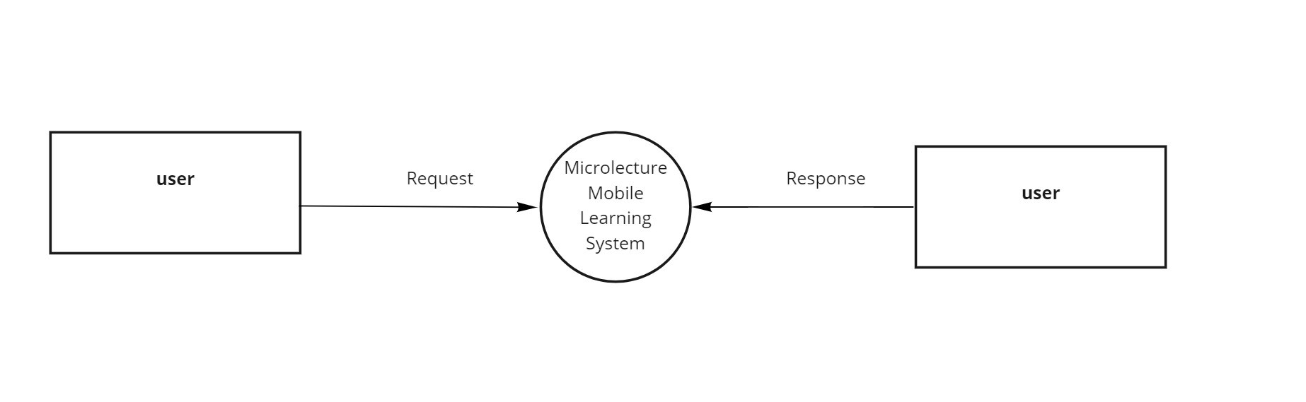

**Level 1 of User**

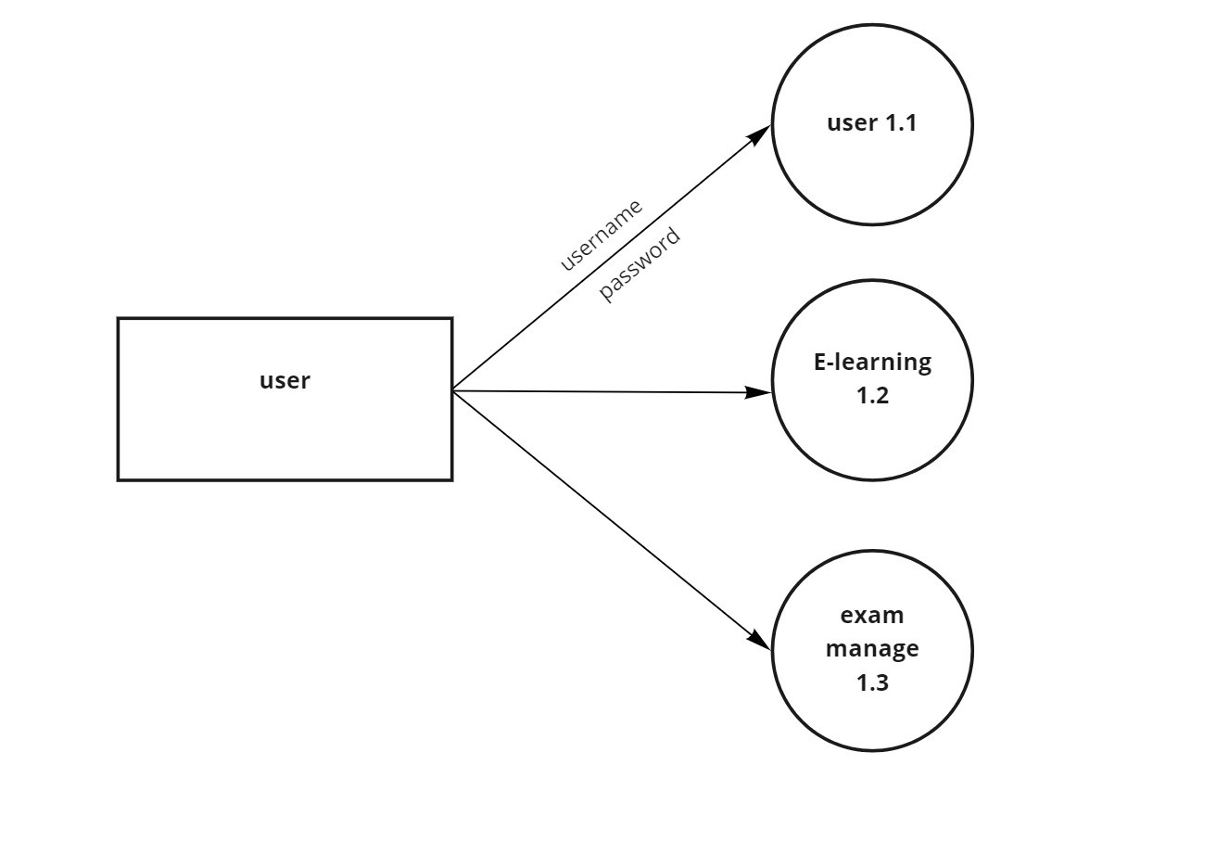

**Level 1.1**

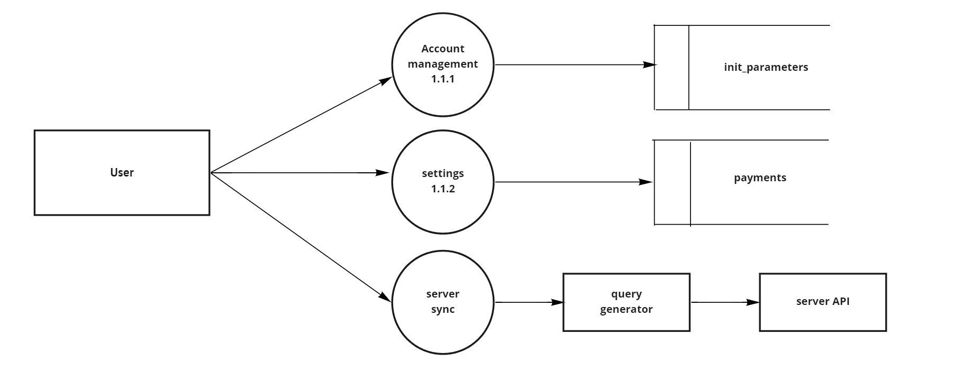

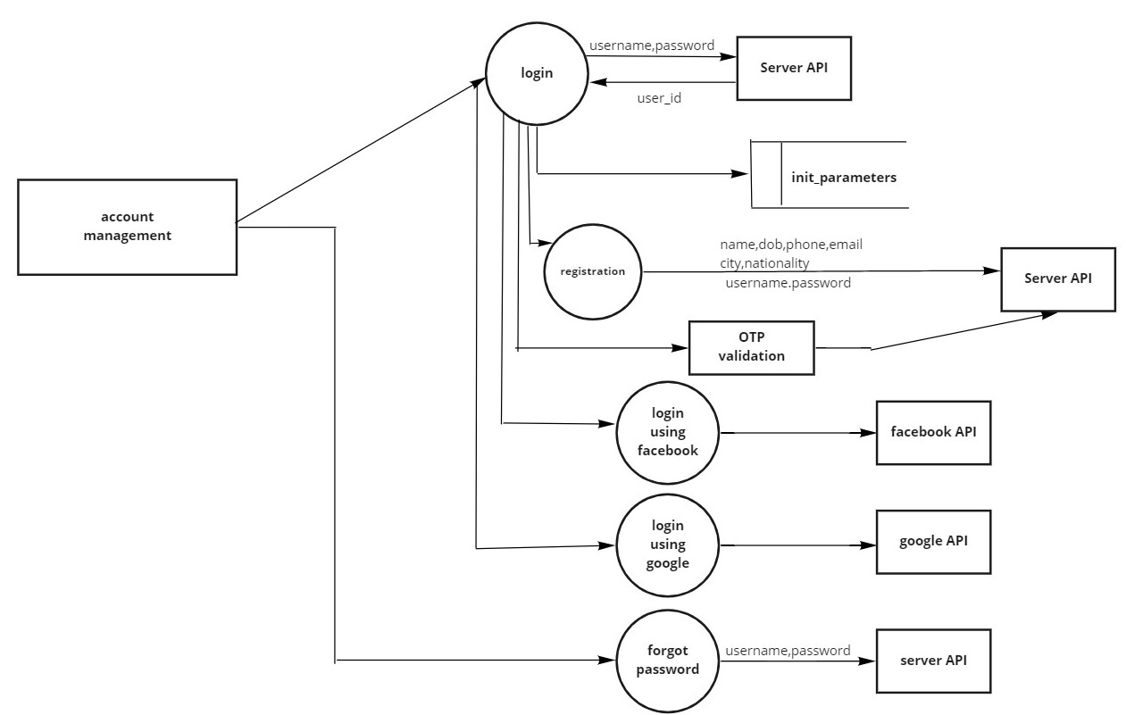

**Level 1.1.1**

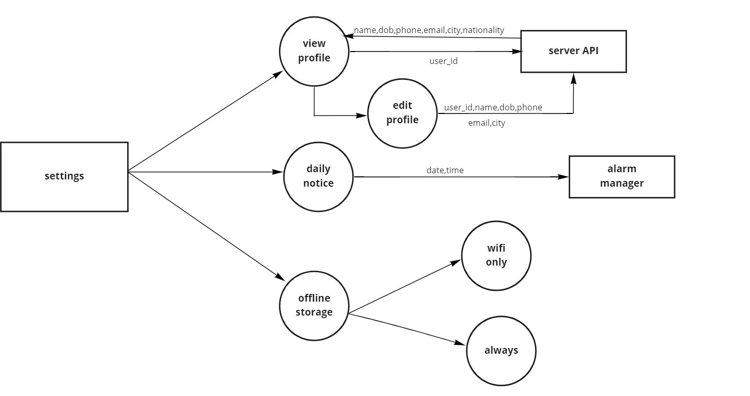

**Level 1.1.2**

**LEVEL 1.2**

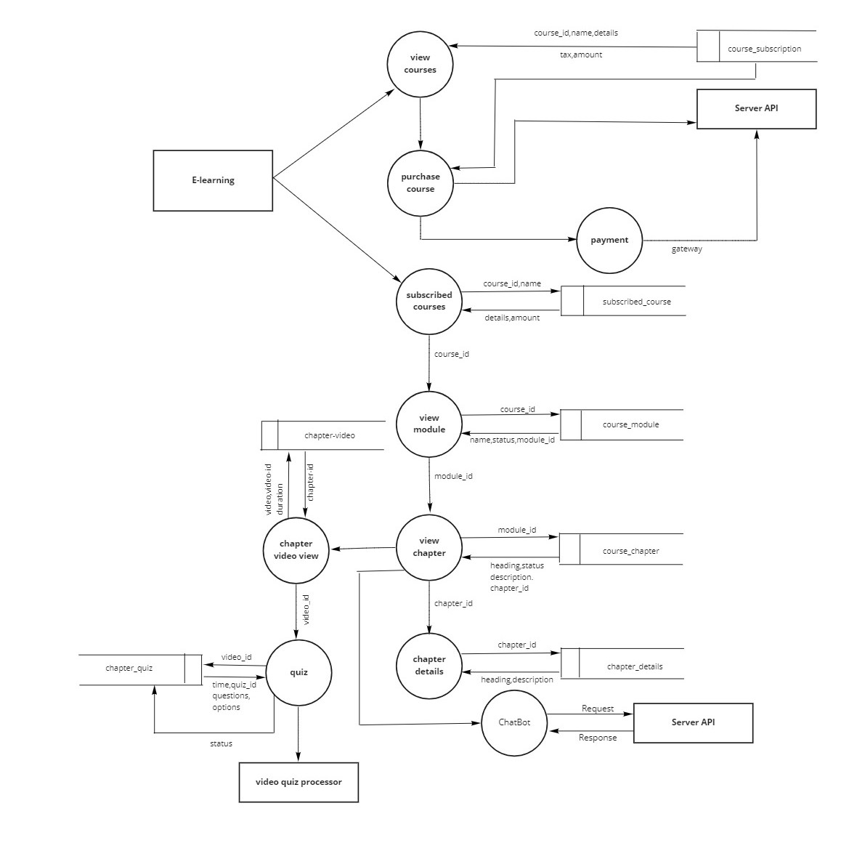

**Level 1.3**

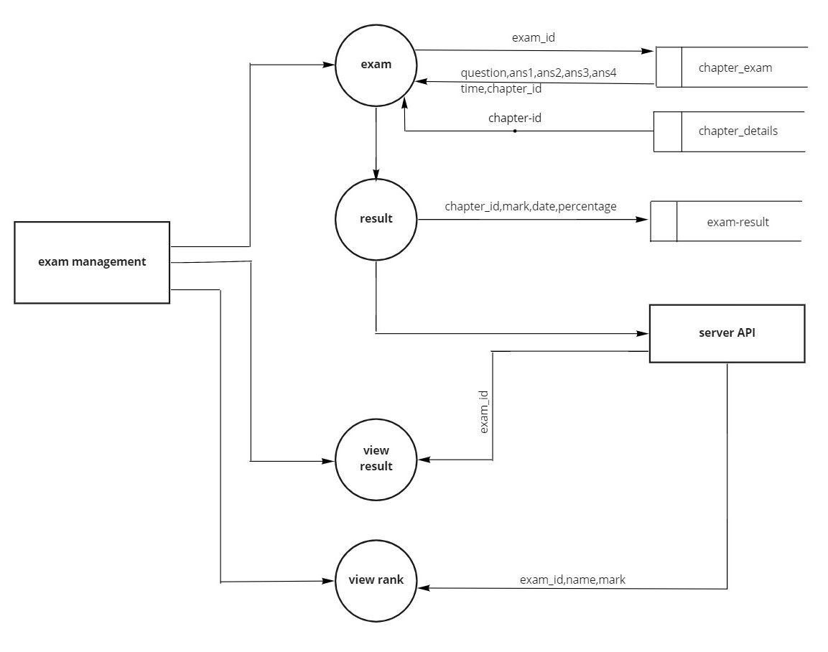

**5.3 DATABASE DESIGN**

A database is a collection of inter-related data stored with minimum redundancy, provides better data integrity and security and also to use many users quickly and efficiently. The general objective of database design is to make the data access easy, inexpensive and flexible to the user. Database design is recognized as a standard of management information system which is virtually available for every computer system.

Database design is the process of producing a detailed data model of a database. This data model contains all the needed logical and physical design choices and physical storage parameters needed to generate a design in a data definition language, which can then be used to create a database. A fully attributed data model contains detailed attributes for each entity.

The term database design can be used to describe many different parts of the design of an overall database system. Principally, and most correctly, it can be thought of as the logical design of the base data structures used to store the data. In the relational model these are the tables and views. In an object database the entities and relationships map directly to object classes and named relationships. However, the term database design could also be used to apply to the overall process of designing, not just the base data structures, but also the forms and queries used as part of the overall database application within the database management system.

The general theme behind a database is to integrate all the information. A database is the integrated collection of data and provides centralized access to data. Usually the centralized data managing software use relational database concepts and hence called RDBMS.

**Design Considerations**

The system is analysed to the requirements and possible tables and fields are determined.

**Identifying Keys**

Once we have drawn upon the list of possible tables and fields, the next step in the logic database is to identify primary key and foreign key of the table.

**Primary Key**

The primary key (PK) of a relational table uniquely identifies each record in the table, it can either normal attribute that is guaranteed to be unique or it can be generated

by the DBMS. Primary keys may consist of a single attribute or multiple attributes in combination.

**Foreign Keys**

A foreign key (FK) is a key comprised of a field or multiple fields that to the primary key of another table. The concept of maintaining foreign keys is known as “referential integrity”.

**Defining Relationship**

A relationship is the term used to describe a connection between related tables. Stated another way, it means having shared fields in different tables that allow records to reference records in other tables. There are three possible types of relationships.

1. **One-to-One Relationships**

A one-to-one relationship indicates that each record in the table may relate to only one in another table.

1. **One-to-Many Relationships**

In a one-to-many relationship, any record in a table can relate to multiple records in a second table.

1. **Many-To-Many Relationships**

With many-to-many relationships many records in one table can link too many records in the second table

1. **Normalization**

Normalization is a process of simplifying the database design to achieve the optimum structure. The steps in this process are known as normal form. These normal forms are a sequence of rules that are applied to progressively a database design. The higher the normal form of a database, the more efficient its underlying design. This is because, for a database to be simplified into third normal form, it must meet the criteria of first and second normal forms.

1. **First Normal Form**

To achieve first normal form, we must eliminate any repeating group. In the first normal form, we simplify our database structure to any repeating group. In other words first normal form include concept that field must be atomic or field represent one type of value for all the records.

1. **Second Normal Form**

To achieve second normal form, we must make sure that the non key fields depends on all the field in primary key every field in the table should be

depend upon the entire primary key so that when new records are added, same value will not be repeated from records to records unnecessarily.

Full functional dependency indicates that if A and B are attributes of a relation, B **is** fully functionally dependent on A if B is functionally dependent on A, but not on any proper subset of A, Second normal form (2NF) is a relation that is in first normal form 35 and every non- primary-key attribute is fully functionally dependent on the primary key. The normalization of 1NF relations to 2NF involves the removal of partial dependencies. If a partial dependency exists, we remove the function dependent attributes from the relation by placing them in a new relation along with a copy of their determinant.

1. **Third Normal Form**

To achieve third normal form, we must make sure that the no fields depend on other non-key fields

1. **Fourth Normal Form**

An entity cannot have a one to one relationship between primary key columns and non-key columns

1. **Fifth normal Form**

Break all tables into the smallest possible pieces to eliminate all redundancy within a table. In conclusion, effective database design can help the development team reduce overall development time and costs. Undertaking the process of database design and creating a data model helps the team better understand the user’s requirements and thus enables them to build a system that is more reflective of the user’s requirements and business rules.

**Database Name:** MicroLectureMobileLearningSystem

Table Number : 5.1

|  |  |  |  |  |
| --- | --- | --- | --- | --- |
| **TABLE NAME: init_parameter PrimaryKey: User_id** | | | | |
| **Description:** **Table for storing student details.** | | | | |
| **Field** | **DataType** | **Size** | **Constraint** | **Description** |
| User_id | Integer | 10 | Primary Key | Id for Students |
| Name | Text | 20 |  | Student Name |
| Phone | Integer | 15 |  | Phone Number |
| Email | Text | 25 |  | Email of Student |
| City | Text | 20 |  | City of Student |
| Nationality | Text | 15 |  | Nationality of Student |

Table Number :5.2

|  |  |  |  |  |
| --- | --- | --- | --- | --- |
| **TABLE NAME:Subscribed_courses**  **PrimaryKey:Course_id** | | | | |
| **Description: Table for storing subject subscription details** | | | | |
| **Field** | **DataType** | **Size** | **Constraint** | **Description** |
| Course_id | Integer | 10 | Primary Key | Id for Subscription |
| Name | Text | 20 |  | Name of course |
| Details | Text | 30 |  | Details of course |
| Amount | Real | 5 |  | Amount of course |
| Tax | Real | 5 |  | Tax |
| Keyword | Text | 10 |  |  |

Table Number:5.3

|  |  |  |  |  |
| --- | --- | --- | --- | --- |
| **TABLE NAME:Course_module Primarykey: Module_id** | | | | |
| **Description:Table for storing course module details.** | | | | |
| **Field** | **DataType** | **Size** | **Constraint** | **Description** |
| Module_id | Integer | 10 | Primary key | Id for course module |
| Course_id | Integer | 10 | Foreign Key | Id of Courses |
| Name | Text | 20 |  | Course name |
| Status | Text | 10 |  | Status |

Table number:5.4

|  |  |  |  |  |
| --- | --- | --- | --- | --- |
| **TABLE NAME:Course_chapter PrimaryKey:Chapter_id** | | | | |
| **Description:Table for storing chapter basic details.** | | | | |
| **Field** | **DataType** | **Size** | **Constraint** | **Description** |
| Chapter_id | Integer | 10 | Primary Key | Id of chapter |
| Heading | Text | 15 |  | Heading of chapter |
| Status | Real | 5 |  | Status |
| Description | Text | 30 |  | Description of chapter |
| Module_id | Integer | 10 | Foreign key | Id of module |

Table Number:5.5

|  |  |  |  |  |
| --- | --- | --- | --- | --- |
| **TABLE NAME:Chapter_details PrimaryKey:Details_id** | | | | |
| **Description:table for storing chapter details** | | | | |
| **Field** | **DataType** | **Size** | **Constraint** | **Description** |
| Details_id | Integer | 10 | Primary Key | Id of details |
| Heading | Text | 15 |  | Chapter heading |
| Description | Text | 30 |  | Chapter details |
| Chapter_id | Integer | 10 | Foreign Key | Id of chapter |

Table Number:5.6

|  |  |  |  |  |
| --- | --- | --- | --- | --- |
| **TABLE NAME:Chapter_video PrimaryKey:Video_id** | | | | |
| **Description: Table for storing chapter videos.** | | | | |
| **Field** | **DataType** | **Size** | **Constraint** | **Description** |
| Video_id | Integer | 10 | Primary Key | Id of video |
| Chapter_id | Integer | 10 | Foreign Key | Id of chapter |
| Video | Text | String |  | Chapter videos |
| Duration | Real | 5 |  | Video duration |

Table Number:5.7

|  |  |  |  |  |
| --- | --- | --- | --- | --- |
| **TABLE NAME:Chapter_quiz PrimaryKey:Quiz_id** | | | | |
| **Description:Table for storing quiz details.** | | | | |
| **Field** | **DataType** | **Size** | **Constraint** | **Describe** |
| Quiz_id | Integer | 10 | Primary Key | Id of quiz |
| Question | Text | 50 |  | Question |
| Opt1 | Text | 20 |  | Option 1 |
| opt2 | Text | 20 |  | Option 2 |
| opt3 | Text | 20 |  | Option 3 |
| Opt4 | Text | 20 |  | Option 4 |
| Ans | Text | 20 |  | Answer |
| Video_id | Integer | 10 | Foreign Key | Id of video |
| Time | Time | 5 |  | Duration |

Table Number:5.8

|  |  |  |  |  |
| --- | --- | --- | --- | --- |
| **TABLE NAME:Exam_result PrimaryKey:Exam_result** | | | | |
| **Description:Table for storing exam result details.** | | | | |
| **Field** | **DataType** | **Size** | **Constraint** | **Describe** |
| Exam_result | Integer | 10 | Primary Key | Id of exam result |
| Chapter_id | Integer | 10 | Foreign Key | Id of chapter |
| Mark | Real | 5 |  | Mark of subject |
| Date | Text | Date |  | Date of result |
| Percentage | Real | 5 |  | Percentage of mark |

Table Number:5.9

|  |  |  |  |  |
| --- | --- | --- | --- | --- |
| **TABLE NAME:Chapter_exam PrimaryKey:Exam_id** | | | | |
| **Description:Table for storing exam detailed.** | | | | |
| **Field** | **DataType** | **Size** | **Constraint** | **Describe** |
| Exam_id | Integer | 10 | Primary Key | Id of Exam |
| Question | Text | 50 |  | Question |
| Ans1 | Text | 20 |  | Answer 1 |
| Ans2 | Text | 20 |  | Answer 1 |
| Ans3 | Text | 20 |  | Answer 1 |
| Ans3 | Text | 20 |  | Answer 1 |
| Ans | Text | 20 |  | Answer |
| Time | DateTime |  |  | Time |
| Chapter_id | Integer | 10 | Foreign Key | Id of chapter |

**5.4 INPUT DESIGN**

The input design is the link between the information system and the user. It comprises the developing specification and procedures for data preparation and those steps are necessary to put transaction data into a usable form for processing can be achieved by inspecting the computer to read data from a written or printed document. The design of input focuses on controlling the amount of input required, controlling the errors, avoiding delay, avoiding extra steps and keeping the process simple. The input is designed in such a way so that it provides security and ease of use with retaining the privacy. In the Input designing we had considered the following things

* What data should be given as input?
* How the data should be arranged or coded?
* The dialogue to guide the operating personnel in providing input.
* Methods for preparing input validations and steps to follow when errors occur.
* It is achieved by creating user friendly screens for the data entry to handle large volume of data.
* The goal of designing input is to make data entry easier and to be free from errors.The data entry screen is designed in such a way that all the data manipulates can be performed. It also provides record viewing facilities.
* Input design is the process of converting a user oriented description of the input into a computer based system .This design is important to avoid errors in the data Input process and show the correct direction to the management for getting correct information from the computerized system.

When the data is entered it will check for its validity. Data can be entered for its Validity. Mostly input data can be selected from a list of data items . Appropriate messages are provided as when needed so that the user will not be in maize of instant. Thus the objective of input is to create an input lay out that is easy to follow. For example in user registration form all the fields except some optional fields must be enter, otherwise display appropriate error message.

**5.5 OUTPUT DESIGN**

Computer output is the most important one to the user. A major form of the output is the display of the information gathered by the system and the servicing the user requests to the system. Output generally refers to the results or information that is generated by the system. It can be in the form of operational documents and reports. Since some of the users of the system may not operate the system, but merely use the output from the system to aid them in decision-making, much importance is given to the output design. Output generation hence serves two main purposes, providing proper communication of information to the users and providing data in a form suited for permanent storage to be used later on. The output design phase consists of two stages, output definition and output specification. Output definition takes into account the type of outputs, its contents, formats, its frequency and its volume. The output specification describes each type of output in detail. Efficient and well defined output design improves the relationship of the system and the user, thus, facilitating design making.

Table Number:5.10

|  |  |  |
| --- | --- | --- |
| **Process** | I**nput Design** | **Output Design** |
| Login page for admin/faculty/user | Enter username ,password | Show home page |
| Register user | Enter user details | If valid, registration successful |
| payment | Enter faculty details | If valid, registration successful |
| Course registration | Enter course details | If valid,registration successful |
| Exam registration | Enter exam details | If valid,registration successful |
| Using Chat Bot | questions | Chatbot showing answers |
| Exam enrolment | Enter user details | Exam enrolment successful |
| Course enrolment | Enter user details | Course enrolled successfully |
| Automatic questioning | Entering answers | Answer saved successfully |

**5.6 PROGRAM DESIGN**

1. **User Module**

**Step 1:** Start

**Step 2:** User can go to Application and register

**Step 3:** After registration loged into the application for viewing,enrolling online video classes and also can enrol for online examination.

**Step 4:** In Course enrolment student can enrol for different subject after that he/she can attend the classes.

**Step 5:** In Exam enrolment student can enrol for online exams after that he/she can attend the online exam.

**Step 6:** User can view the exam results.

**Step 7:** User can use chatbot for clearing their doubts during offline classes.

**Step 8:** Stop.

**CHAPTER 6**

**FUNCTIONAL AND NON-FUNCTIONAL REQUIREMENTS**

**6.1 FUNCTIONAL REQUIREMENT**

In software engineering, a functional requirement defines a function of a software system or its component. A function is described as a set of inputs, the behaviour, and outputs. Functional requirements may be calculations, technical details, data manipulation and processing and other specific functionality that define what a system is supposed to accomplish. Generally, functional requirements are expressed in the form "system must do requirement ".

Functional requirements for each of the uses cases described below:

1. The system shall have options from which the users can view all subjects that are provided by the institution.
2. The system shall provide functionality for the Faculty to register exams.
3. The system provides a space for the user to attend online classes without any interruption
4. The system shall provide the admin to control all other users.
5. The system shall provide an environment to the user for online examination.

**6.2 NON-FUNCTIONAL REQUIREMENTS**

A non-functional requirement is a requirement that specifies criteria that can be used to judge the operation of a system, rather than specific behaviours. Non-functional requirements are “system shall be requirement ". Non-functional requirements are often called qualities of a system. Other terms for non-functional requirements are "constraints", "quality attributes”, “quality goals", "quality of service requirements" and "non-behavioural requirements. Some of the non-functional requirements are mentioned below:

1. **Usability:** The system shall have a clean interface with only needed features, clear terminology and tool tips wherever necessary. Warnings or alerts shall be specified in clear way.
2. **Efficiency:** The system shall respond to different searches being conducted like searching particular courses in a very fast way.
3. **Interoperability:** The system shall be able to interact with other systems. The system should able to be supported at least one software which has a relationship with payment process.
4. **Reliability:** Reliability defined as a measure of the time between failures occurring in a system (measure show frequently the system fails), so that the system shall operate without any failure for a particular period of time.
5. **Availability:** Availability measures the percentage of time the system is in its operational state so that the system shall be available for use 24 hours per day and 365days per year.

**CHAPTER 7**

**TESTING**

**7.1 TESTING STRATEGIES**

An engineered product can be tested in one of these two ways. These testing strategies include:

* Black box testing
* White box testing

**Black box testing**

Black-box testing is a method of software testing that examines the functionality of an application without peering into its internal structures or workings. This method of test can be applied virtually to every level of software testing: unit, integration, system and acceptance. It is sometimes referred to as specification-based testing.

**White box testing**

White-box testing is a method of testing the application at the level of the source code. White-box testing (also known as clear box testing, glass box testing, transparent box testing, and structural testing) is a method of testing software that tests internal structures or workings of an application, as opposed to its functionality. In white-box testing an internal perspective of the system, as well as programming skills, are chooses inputs to exercise paths through the code and determine the expected outputs.

**7.2 UNIT TESTING**

In computer programming, unit testing is a software method by which individual units of source code, sets of one or more computer program modules together with associated control data, usage procedures are tested to determine whether they are fit for use intuitively, one can view a unit as the smallest testable part of an application. In procedural programming a unit could be an entire module, but it is more commonly an individual function or procedure. In object-oriented programming, a unit is often an entire interface, such as a class, but could be an individual method. Unit tests are short code fragments created by programmers or occasionally by white box testers during the development process. If forms the basis for component testing.

**7.3 INTEGRATION TESTING**

This is the final step in testing. In this case all the modules were combined and given the test data. The combined module works successfully without any side effect on other programs. Everything was found to be working correctly. In this the entire system was tested as a whole with all modules. This form of testing is popularly known as Black Box testing or system testing. Black Box testing methods focus on the functional requirement of the software. That is, Black Box testing enables the software engineer to derive sets of input conditions that will fully exercise all functional requirements for a program. Black Box testing attempts to find errors in the following categories; incorrect or missing functions, interface errors, errors in data structures or external database access, performance errors and initialization errors and termination errors.

**7.4 SYSTEM TESTING**

Testing is a set activity that can be planned and conducted systematically. Testing begins at the module level and work towards the integration of entire computers based system. Nothing is complete without testing, as it is vital success of the system.

**Testing Objectives:**

There are several rules that can serve as testing objectives, they are

* Testing is a process of executing a program with the intent of finding an error
* A good test case is one that has high probability of finding an undiscovered error.
* A successful test is one that uncovers an undiscovered errors.

A test case is a specification of the inputs, execution conditions, testing procedure, and expected results that define a single test to be executed to achieve a particular software testing objective, such as to exercise a particular program path or to verify compliance with a specific requirement. Test cases underlie testing that is methodical rather than haphazard. A battery of test cases can be built to produce the desired coverage of the software being tested. Formally defined test cases allow the same tests to be run repeatedly against successive versions of the software, allowing for used to design test cases. The tester effective and consistent regression testing.

**7.5 TESTING RESULTS**

|  |  |  |  |  |
| --- | --- | --- | --- | --- |
| **SI no** | **Test case** | **Input** | **Expected Output** | **Result** |
| 1 | Login Page(user) | Username,password | User Dashboard | Pass |
| 2 | Subscribe Courses | Name,Course name | Subscription successful | Pass |
| 3 | Search course | course_id | Course details | Pass |
| 4 | View video | course-id | Course video | Pass |
| 5 | Use chatbot | questions | Answer displayed successful | Pass |
| 6 | Registering exam | user_id,name | Exam registered successful | Pass |
| 7 | View result | user_id,exam_id | Result displayed successful | Pass |
| 8 | Edit profile | Name,address,place,phone,email | Profile updated successful | Pass |
| 9 | Register using Facebook | Username,password | Register successful | Pass |
| 10 | Course Payment | Course name,amount | Payment successful | Pass |

**CHAPTER 8**

**RESULTS AND DISCUSSION**

**8.1 Results (Salient Features)**

The main motivation and objective of this system MICRO LECTURE MOBILE LEARNING SYSTEM is to provides flexible and feasible environment for learning process. We need more time saving and more accurate learning system as the number of applicants is increasing day by day. Micro lecture mobile learning system fulfil this need by using ,a Platform as a Service mobile cloud environment where those online videos classes and video-quizzes are stored and streamed. By applying computational offloading, the videos are streamed to a group of users in a classroom.

Once the videos are uploaded in the system, the system divide the video into different frames and in each frames different questions are asked to the students related to the covered topics. The video continues only after student answer’s the question. This minimizes the chance of “bunking” the offline video classes. Online learning system gives you the flexibility to evaluate and grade Students performance.

The proposed system incorporated with the following features:

* Offline video saving.
* Online video streaming.
* Inline mandatory quiz sessions.
* Video analytics.
* Chatbot.
* Online frame selection.
* Online exam.
* Cloud server integration.

**8.2 SCREEN SHOTS**